Problem 1
ERD 1.0

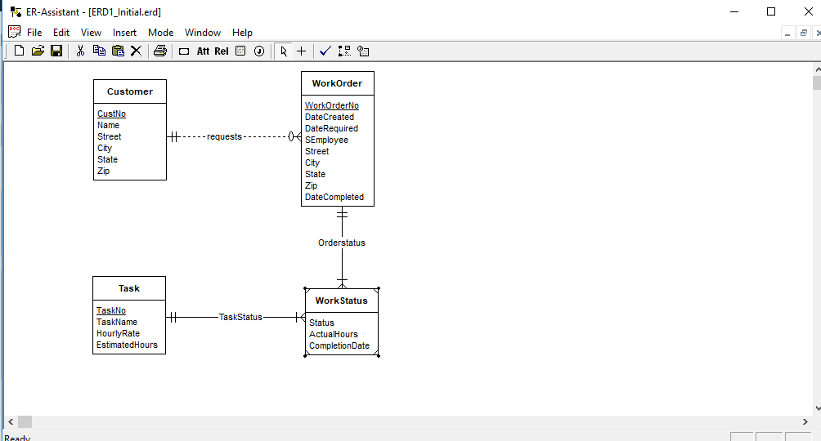

ERD 1.0
- Considering the First Requirement Material Entity was added with attributes as mentioned.
- WorkOrder and Materials Have M-N relationship, it is decomposed into two parts (1-M) relationship.
- EstimatedHours is deleted from Task Entity and was added in the Weak Entity WorkStatus.

